***BIOSHOCK ANALYSIS***

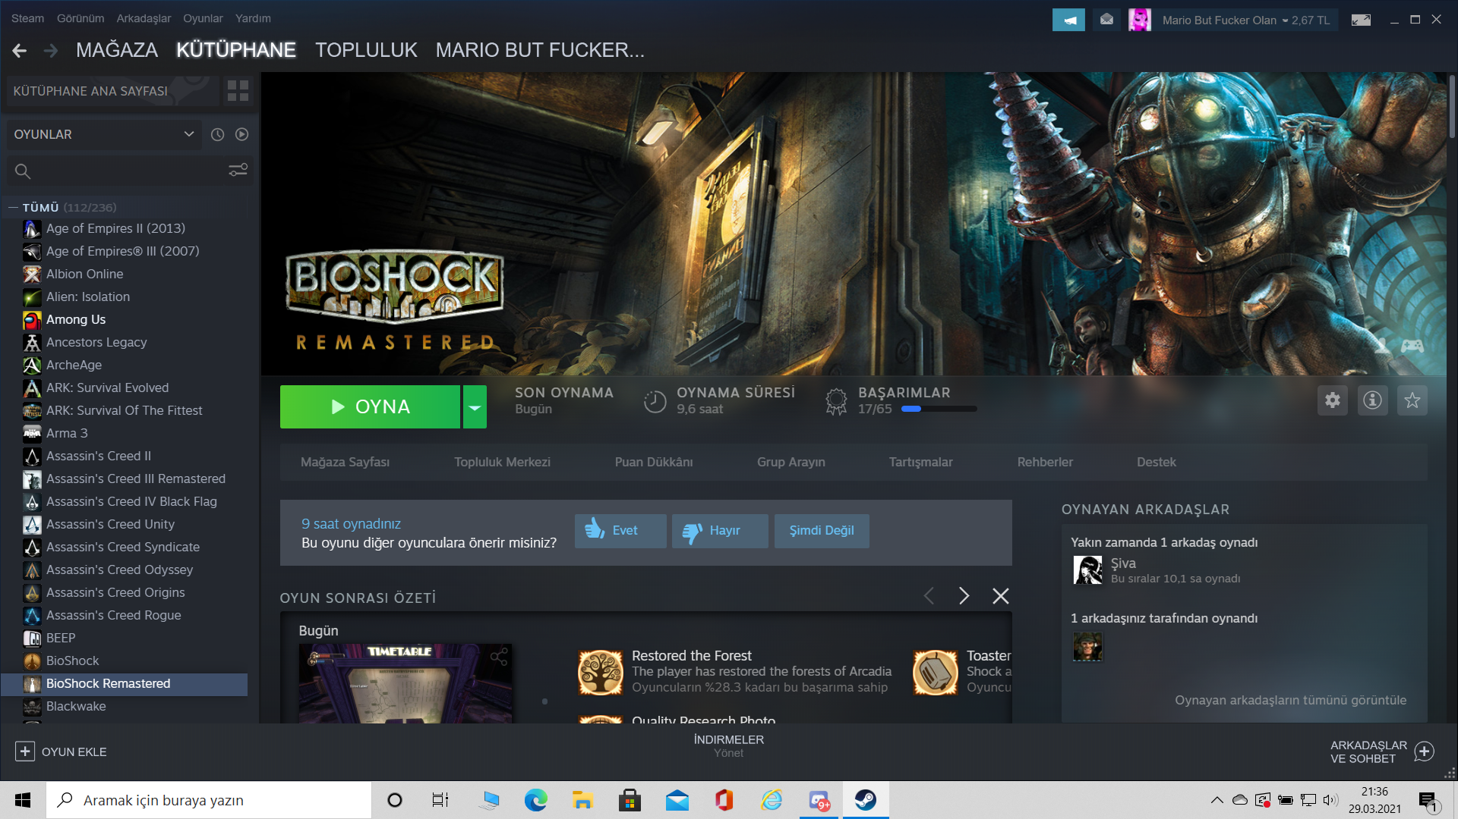

**Playability:**

Bioshock has incredible mechanics and features for 2016. The game is an underwater-themed game and takes place in an underwater city. Game’s interface is a little bit complicated, it’s not a player friendly, there is a lot of features there and players can’t choose or see all of them, always you need scroll and find what do you want (for game’s first hours you can’t understand what do you want) because of theese reasons it’s very complicated for players. Secondly game has a lot of bugs and technical problems. For instance; when you use the camera, game constantly crushed (it’s happened a lot of times and i didn’t save it …), by the way if you don’t take save frequently your game will be like hell because game’s autosaves taken every 30 mins. All in all game hasn’t got a good interface, avarage bug system and playability.

(I give 5/10 points to Playability)

**Story:**

First of all, I couldn’t understand game’s story because of game’s timing. When you find something about story a lot of mutants attack to you and you can’t focus on to story. I learn a lot of things but when I finished I readed story, with that point everything been clear. Our story started with plane crash you falled middle of the Atlantic Ocean and you find the light tower after that you discovered to Rapture (Our underwater city’s name). You learn what is it and what happened there, you find a lot of video cassette and thoose are explain to facts. When players play final chapter probably they will react the same as me (is that all ?). Final boss is very easy one and it’s has very bad effect on game’s story it musn’t finished with that if I write that game’s final it will be harder then that one. All in all, game has good story but developers couldn’t calibrated explanations and game’s actions (for me I couldn’t fight and read at the same time).

(I give 7/10 points to Story)

**Enjoyment:**

Normally I don’t play story based games but Bioshock hold me and said you can play me because I have a lot of amazing battle comps and tactics, for example; hacking something, when you hacked robots they will fight for you or when you try to hack somethings there is a water mazes and you try to find true way for water and finally good weapons (specially shotgun, I loved it). I loved weapons but there is a thing, how the shotgun can be more powerfull then rocket launcher, that’s so absurdity and it’s force players use to shotgun. When you try to speed run game block you, always you need loot something if you don’t you will failed. All in all game’s enjojment is high and when you play bioshock you spend good hours.

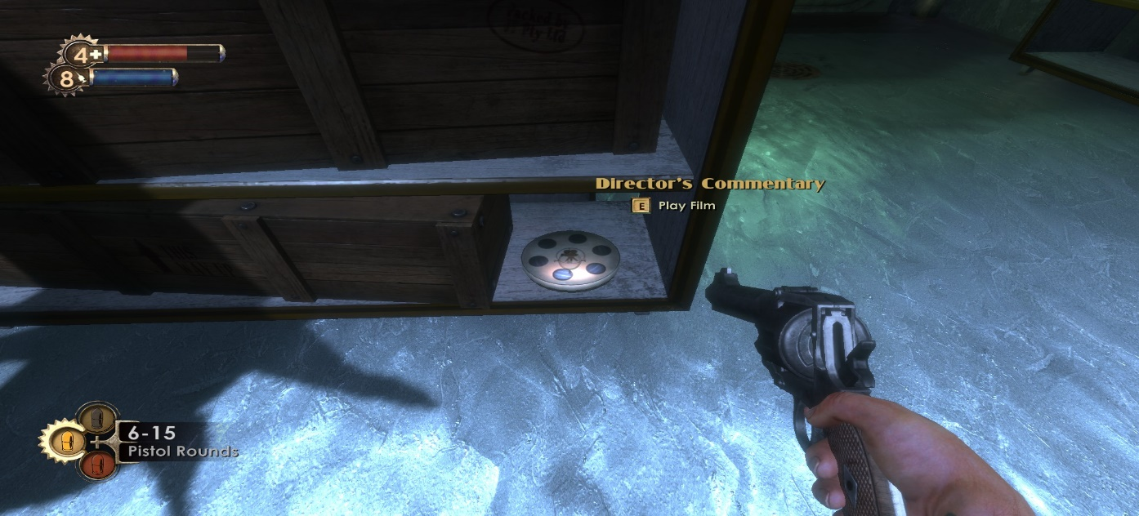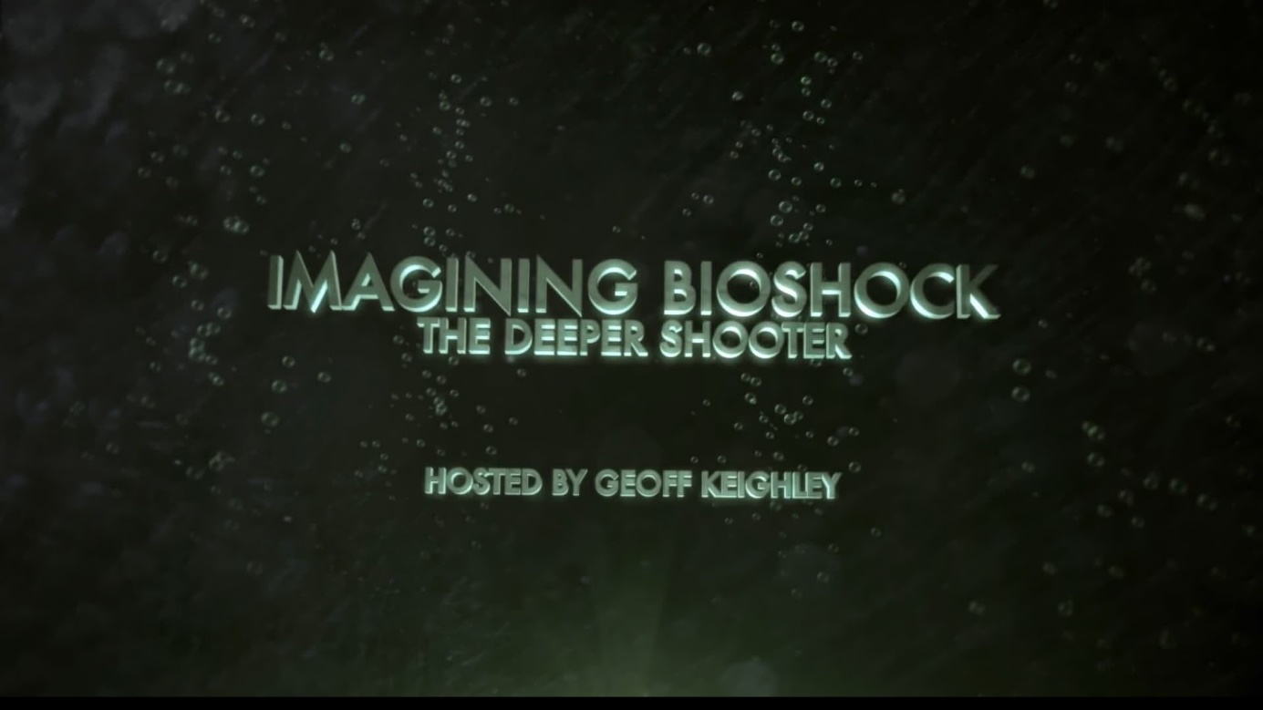

( That special videos add extra enjoyment to game)

(I give 8/10 points to Enjoyment)

**Visual Aesthetics:**

I can’t find true words for games visual features, they are incredible, I love they and if i’m not mistaken every single player love it. When I play game if game has good visual quality I fall inside to game’s story. Respect for developers because that graphics and details progress are not easy, when you walk on the middle of water, water drops to strew around or when you fire you can feel that effects and it’s make happy. Game has amazing views, there is a underwater city there and developers convey it very well. For example that;

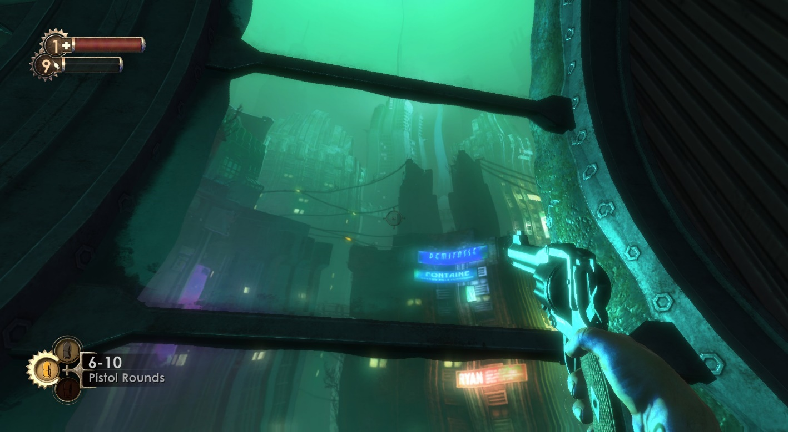

I love flamethrower’s fire types look likes;

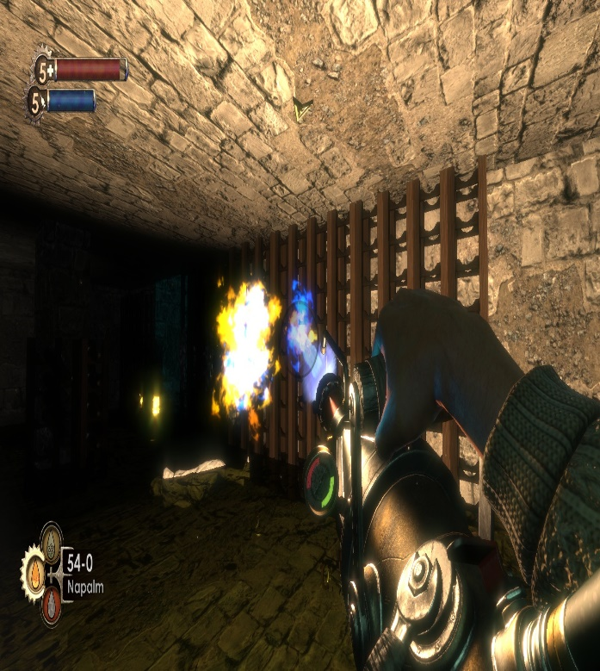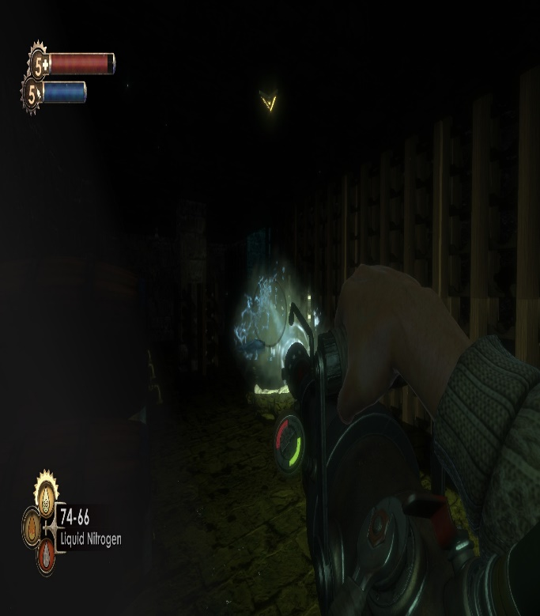

I loved drinking times, you can be drunk and it’s look likes is amazing;

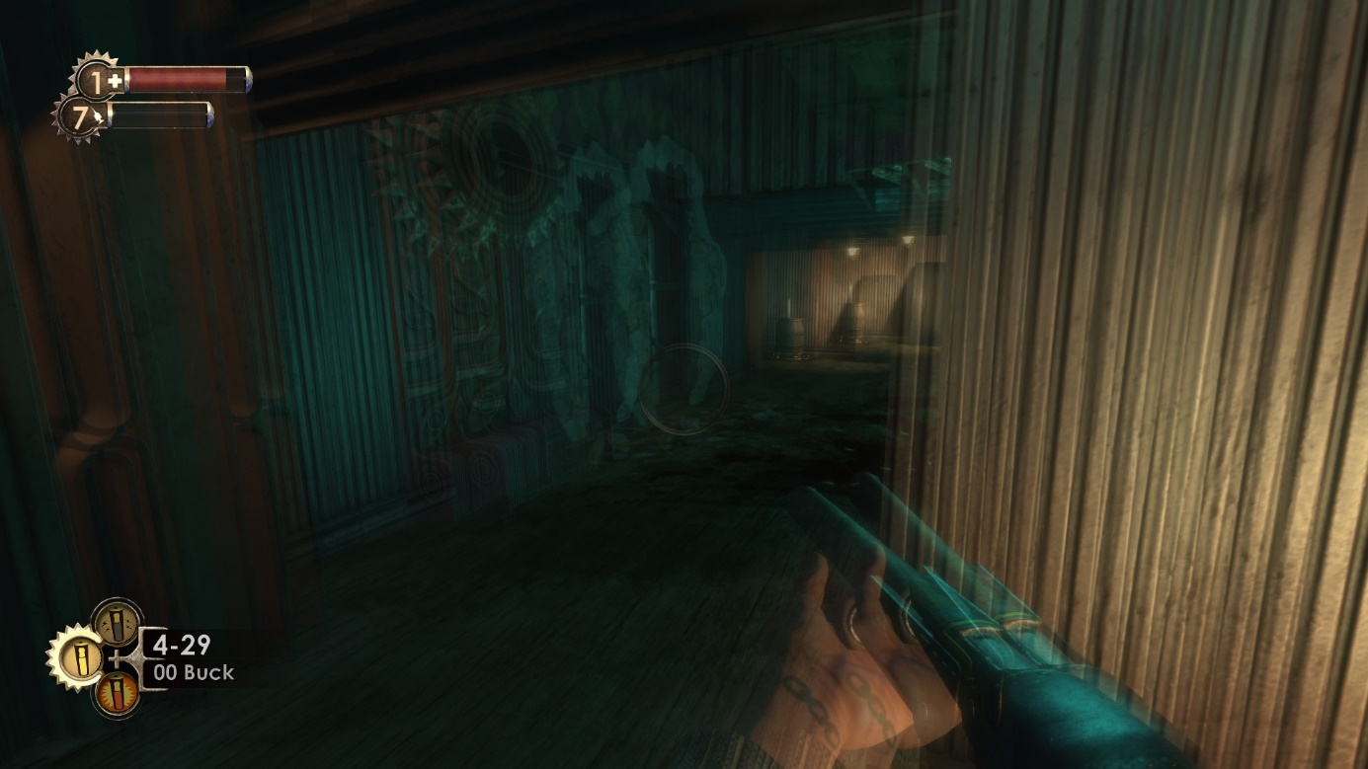

Finally, in the game every single object has shadow but our character hasn’t, i don’t know is it a bug or something else.

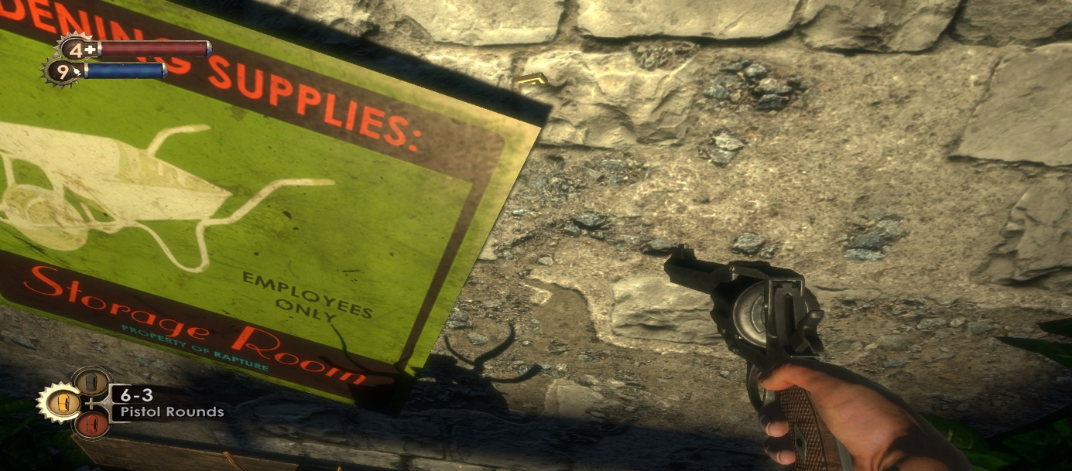

All in all, game’s has very good visual aesthetics and in my opinion it has very good effect on game’s story.

(I give 10/10 points to Visual Aesthetics)

**Audio Aesthetics:**

Game’s audios are amazing, every sing sounds are compatible with game’s story’s progress, when you search somethings game gave adventure music when you fight against to somethings game gave battle music every single object has different sound for example if you use pistol it has a tiny fire sound but if you use rocket that gun has very very high sound or in the gamet here are a lot of big fathers there (they protect to little girls) and they have incredible sound you can feel when they be angry. When you make progress on game’s story very good sounds and musics start and it improve game’s enjoyment. All in all game has amazing musics and sound effects, that features has importances on game’s story developers got it very good.

(I give 10/10 points to Audio Aesthetics)

**Difficulty:**

First of all Bioshock is a very hard game if you don’t play it before probably it will be difficult at first because of war mechanics but after that players can understand it but it’s be still hard. I played average level but it’s too hard for me, every monster has very powerfull damages and you can’t dodge they easily if you haven’t got medical kit probably you will start again and game give very small amount of bullet. By the way game show every single objective what do you do,

for example;

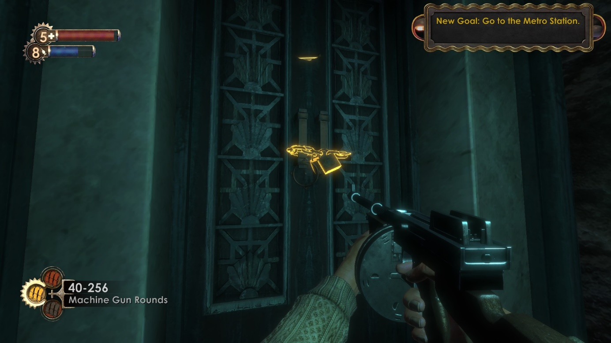

All in all, game is hard for newbies but you can understand it.

(I give 8 points to Difficulty)