***FROSTPUNK ANALYISIS***

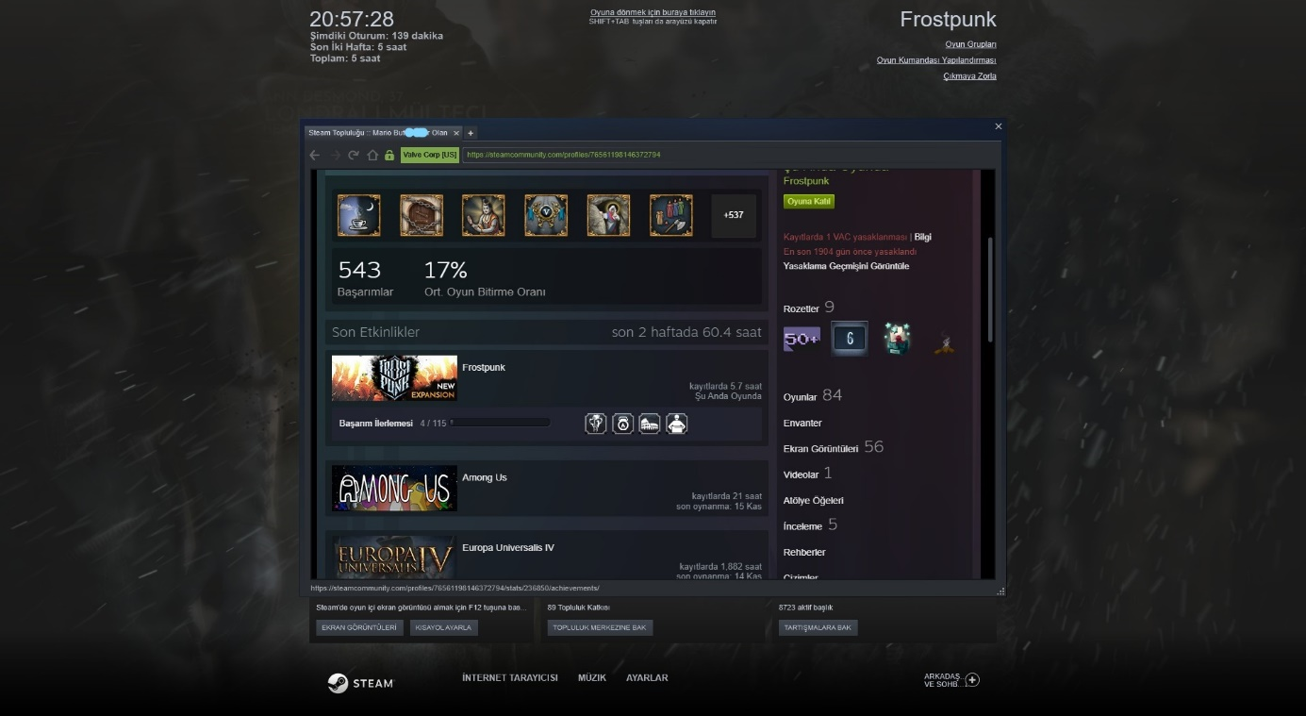

Playability:

First of all, game is impress to me because of every special details are amazing. Normally i’m a grand strategy gamer and Frostpunk is a very very special game for me. If you are a grand strategy gamer too, you shoul play Frostpunk or if you are challanger gamer and you like hard games you can play it but other players (without gamer who likes good graphices) probably don’t like it because of the hardness. All in all game mechanics are confortable and every informations can understand easily.

(I give 7/10 points to Playability)

Story:

There are a lot of story here but i will write about first story (opening story). They are sufferer from colds and their group find a reactor. Everything start with that. In general there is almost no story here but every single part has privet story or feature. For example; when you build scout (Scout is a special building in game) game give a mission, you try to find other sufferers and if you find they, game has animations for theese situation or when you find first automaton game show it with animation and people who live in your city give reaction to automaton. To sum up game has no big story but every detail has different story and in my opinion game developers want, players collect they and make a story..

(I give 5/10 points to Story)

Enjoyment:

If you are a grand strategy gamer, absolutely like Frostpunk. When you start to play game make player to be part of game. It feels like you’re in the game and because of that game’s enjoyment is too high. I played 5 hours and i couldn’t understand how 5 hours passed. Game feel always concerned and when you feel good and be relax game constantly be harder than past and you can’t understand what’s happened. This situations are always give extra points to game when game is grand strategy. Always you must do something when you stop something happend, for instance; You give order to workers for steel mine progress at the same time colds come and you must use worker but they are die because of the cold… system doesnt’t give a permision for fix problems. All in all, every bad situtations give new goal and always this situations give enjoy.

(I give 7/10 points to Enjoyment)

Visual Aesthetics:

I played with extra high graphices and i can’t choose true words for this unique view. Every detail feels like you are here too. When colds come screen’s corners to ice up. When workers try to go any building, game show worker’s footprints on snow and its slowly covered with new snow. Reactors and factories smokes details feel very intense because when smokes to lift enought they strew slowly and it’s add realism to game. If you are in winter season, i should gamers play Frostpunk because game’s atmosphere is suitable with winter. All in all, 11 Bit Studio did it, they created very good graphices and very good atmosphere.

(I give 7/10 points to Visual Aesthetics)

Audio Aesthetics:

Game athosphere is amazing and i wrote it to every headline but game audio ... Game songs, scene sound effects, your workers and companies working sounds, every single notification’s sound feel cold. Game songs and sounds always feel cold on the other hand when you turns to reactor on, it’s activity sound effect feel warm and safe. All in all, if you love feeling atmosphere and if you want cold i should to Frostpunk.

(I give 9/10 points to Audio Aesthetics)

Difficulty:

First of all, if you are not like to strategy games or if you are not challenger player i shouldn’t you to Frostpunk. Frostpunk is a really hard games for who don’t play strategy games or who is newb from strategy games because of that if you like to pass to hard challenges or always going be carefully you must buy it. In Frostpunk you never choose good or bad decision, always pick bad or very bad and this option make it more difficult then other strategy games. When you say oh thats not bad option it’s decision bring disaster and everything what did you do collaps so you will fail. All in al lif you are a hardcore player if you want fight against to hardness Frostpunk is a true choice for they but if you are newb or you are far from strategy i should they don’t buy it, probably they can’t enjoy.

(I give 9/10 points to Difficulty)

MY FIRST RUN I CHOICE TYRANT TYPE AND I COULDN’T USE MY SSSSPOWER TO PEOPLES BECAUSE OF THATMY PEOPLE EXECUTE ME …