THE LONG DARK ANALYSIS

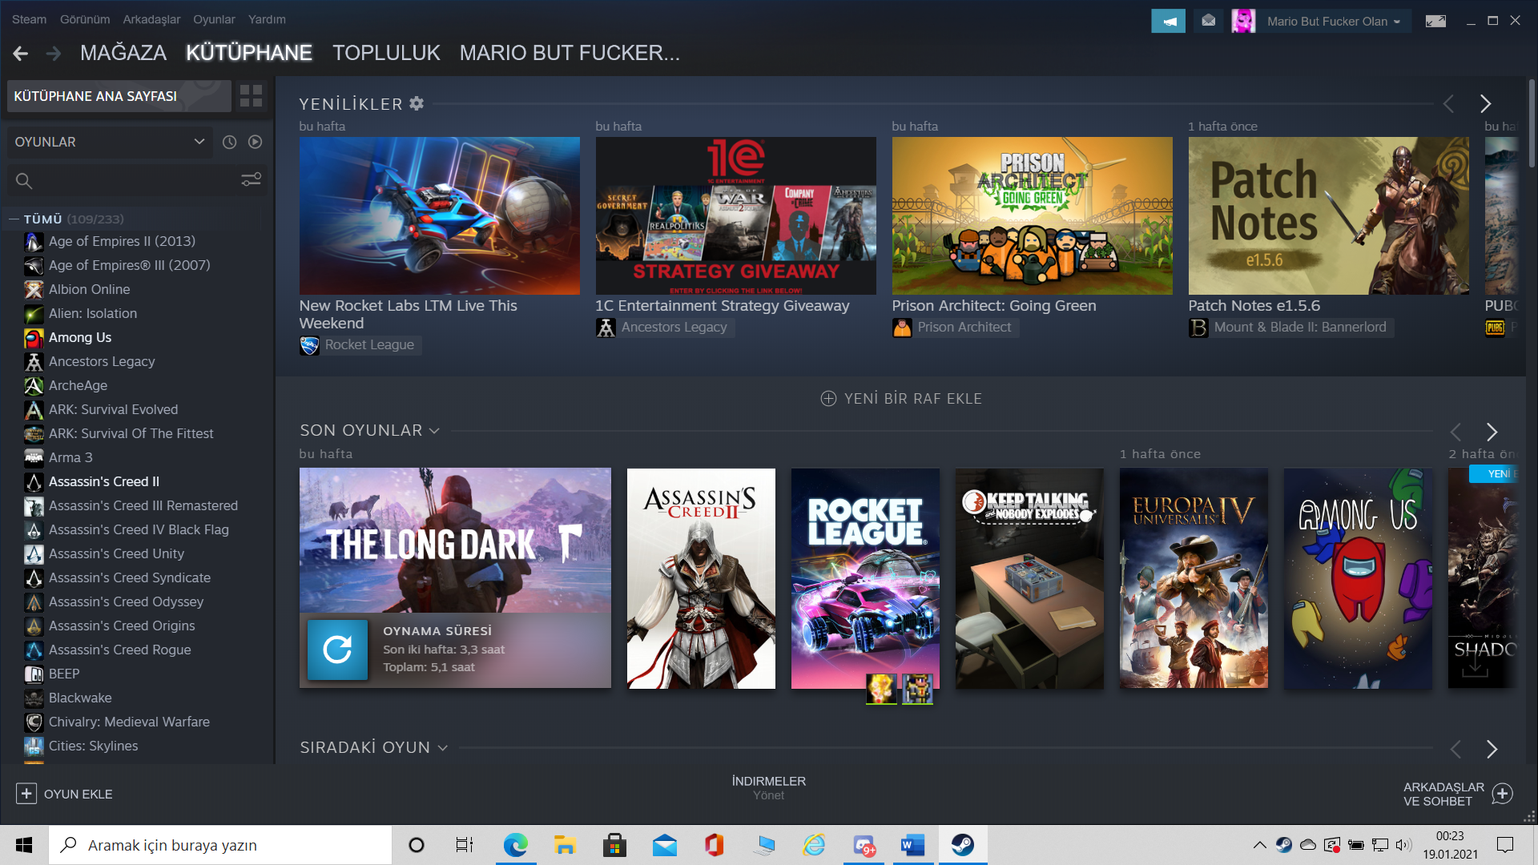

Playability:

First of all, i’m not a hard story game gamer because of that i couldn’t love The Long Dark but if you’re maybe you can. Game’s move mechanics are easy and understandable but there is a lot of wrong mechanics there. For example; game’s loot mechanics are very very bad. Why? Because you can’t find anything and your bag’s capacity’s is very very little. When you need something you can’t find it or when you find you haven’t got a free place for it. Other example is game’s clue system. Game’s informations are not enought for find for clue maybe game’s developers can add better stuffs for clues. All in all game has a lot of problems but if developers fix it game can be perfect.

(I give 4/10 points to Playability)

Story:

I played just 5 hours and there is a simple story there. Game didn’t explain all details but you can understand something and interpert something. I will finish the long dark because of my gamer type (if i start a game i’m always finish it, good or bad doesn’t matter). In general probably game has good story but i couldn’t get good improve because of bad looting system and enigmatic clue problems. Finally, there is a good story here and story gamers like it with high percent.

(I give 5/10 points to Story)

Enjoyment:

Game’s enjoyment is very individual option because of that reason i will explain it skin deep. In general, game is boring you can do what do you want, always you must game’s leads if you don’t crisis break out (hungry, thirsdy). Therefore game’s enjoyment is not perfect and not clear. All in all, it’s not best game ever on the other hand it’s not worst game ever.

(I give 5/10 points to Enjoyment)

Visual Aesthetics:

Game’s atmosphere is awesome, always you can feel cold and there is good effects and graphics there. When you throw a rock and it drop on snow players can watch snow’s pieces rise or when storm coming you can understand it because of weather’s look. All in all there is a good effects and atmosphere there and every players can feel cold because of that players can love The Long Dark’s visual aesthetics.

(I give 8/10 points to Visual Aesthetics)

Audio Aesthetics:

I explained something about game atmosphere in my visual aesthetics analysis, it’s perfect and game’s look like feel cold on the other hand game’s songs are perfect and amazing too. Why? Because every single piece of written music feel like as if you live in The Long Dark’s universe. When you try to find a clue game give exciting music, players feel high stress and choose decision fastly and it’s impress game improvment (yes, audio aesthetics good this much).

(I give 8/10 points to Audio Aesthetics)

Difficulty:

Firstly, players can choose game’s difficulty, there is three different option there, first one is begginer’s option, if you are a newby player for survival games you can choose it. Secondly, middle hardness option there, if you know something about survival gaming and how you can survive, just pick it and start. Thirdly, the hardest option. If you are a hardcore gamer (i picked it) you can choose it and start to nightmare. All in all there is three different diffuculty option here and it’s good feature for game.

(I give 7/10 points to Difficulty)